**Modelling in Biology: Coursework**

# **Part 1: Dynamical systems**

**Question 1: Diagonalization, in your own words**

**See written solution**

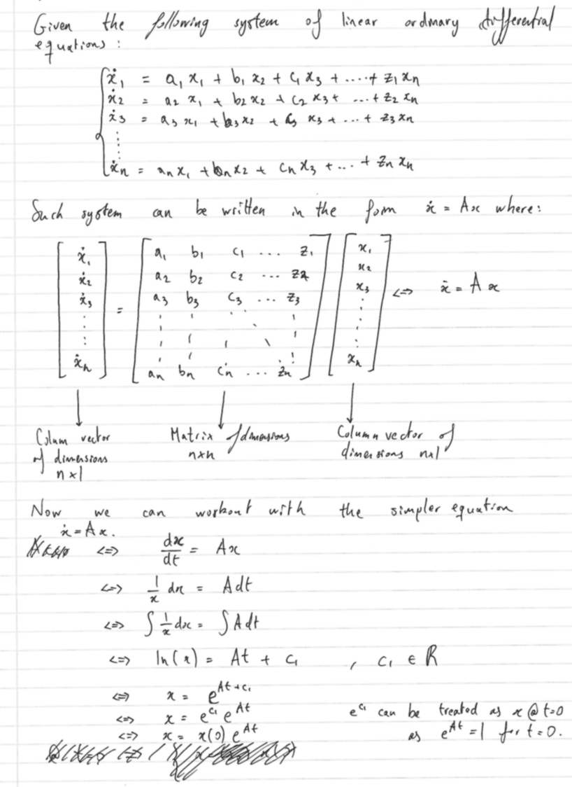

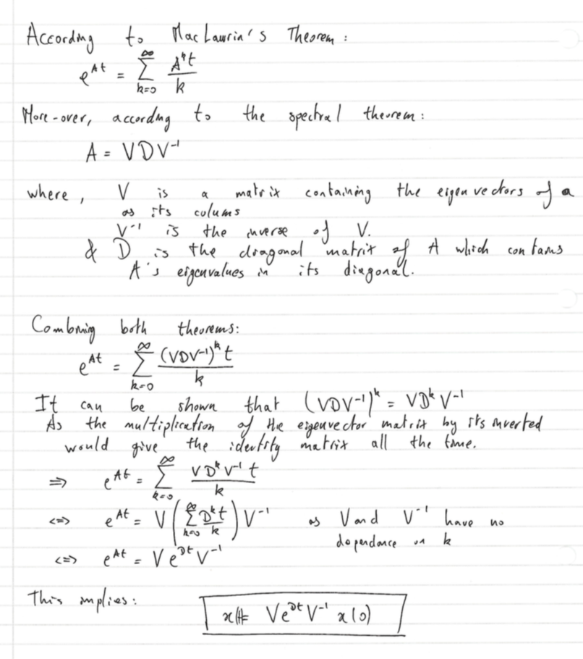

**Question 2: Bifurcation analysis**

**See written solution**

**SYSTEM 1**

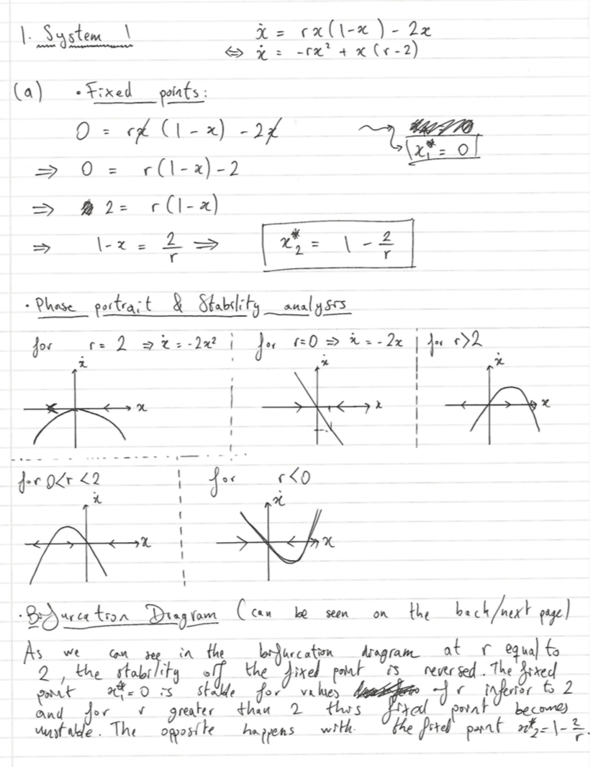

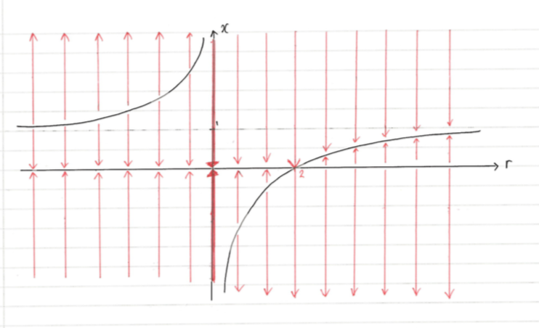

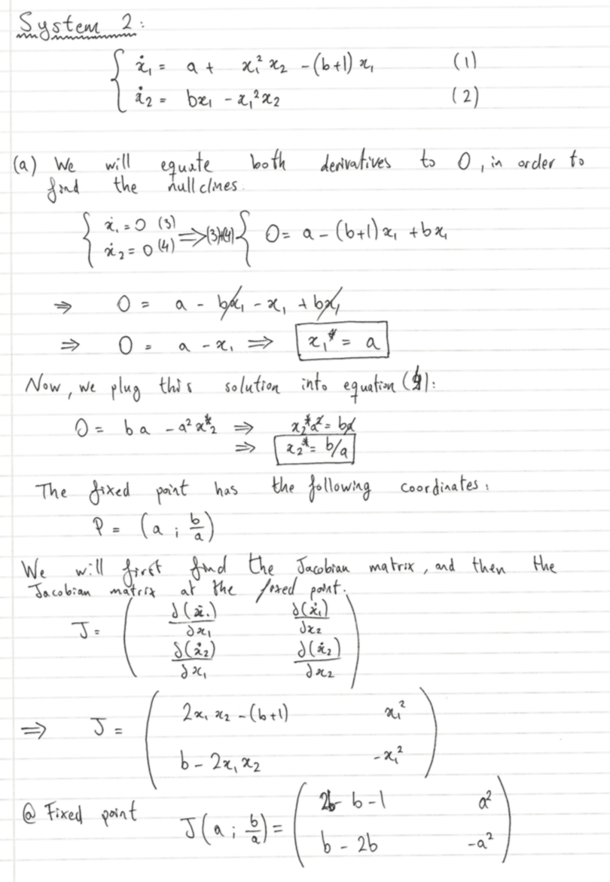**SYSTEM 2**

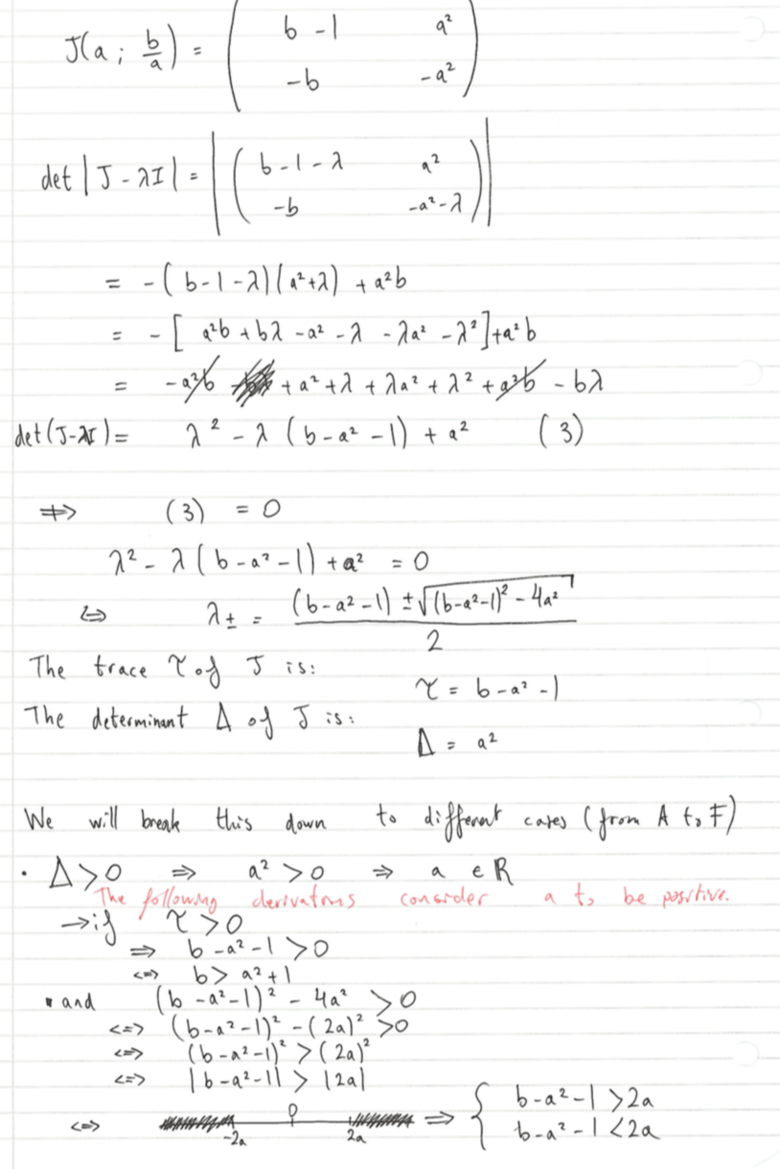

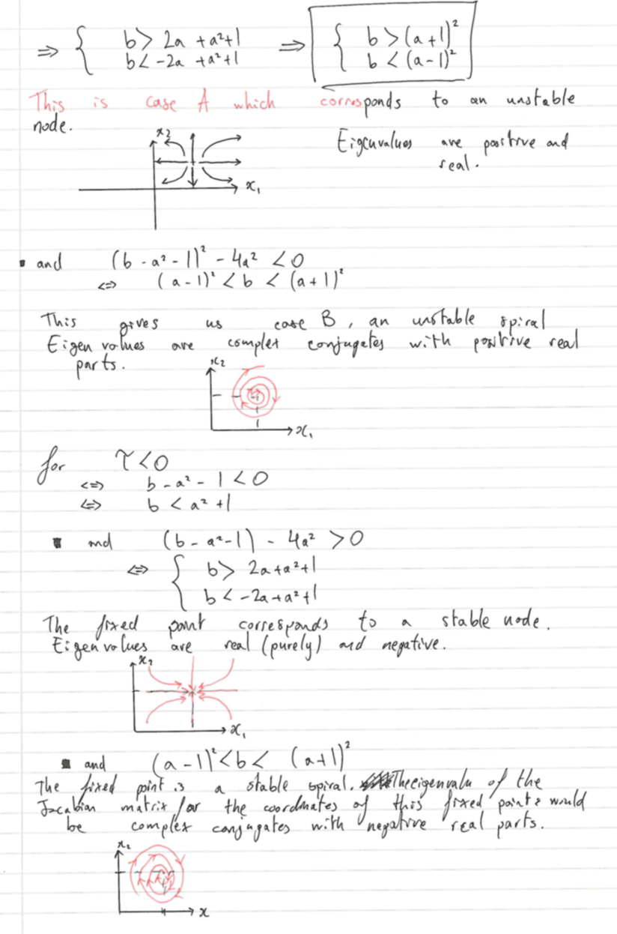

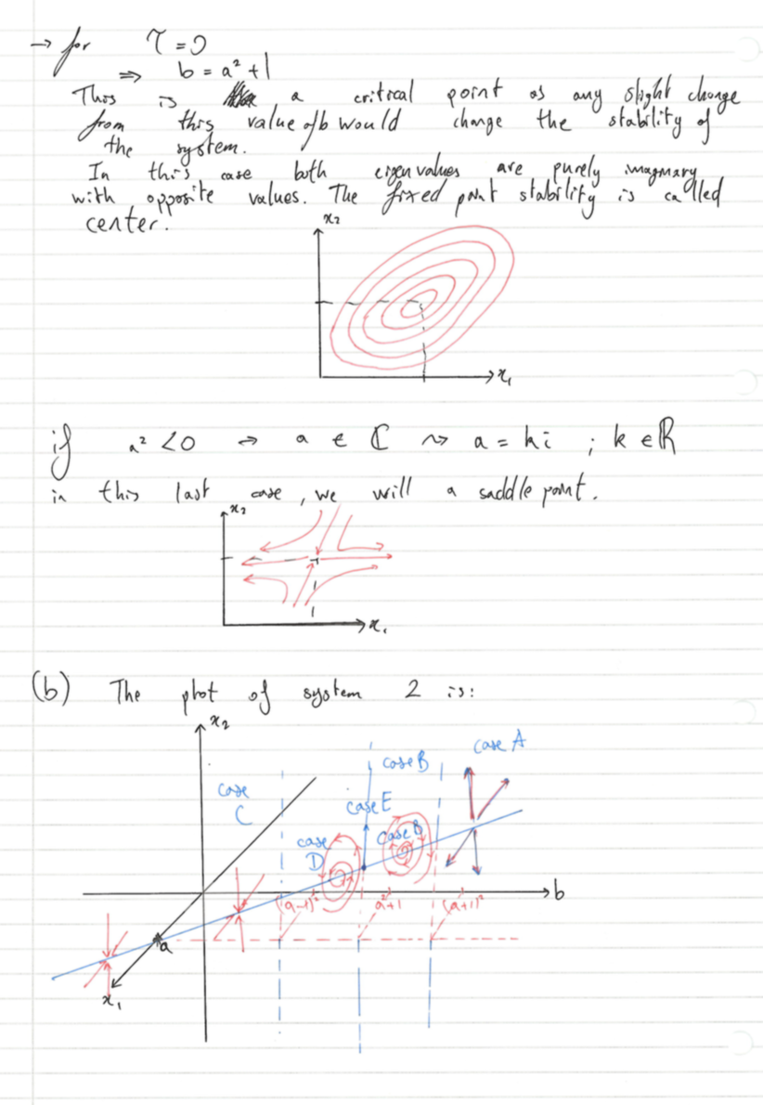

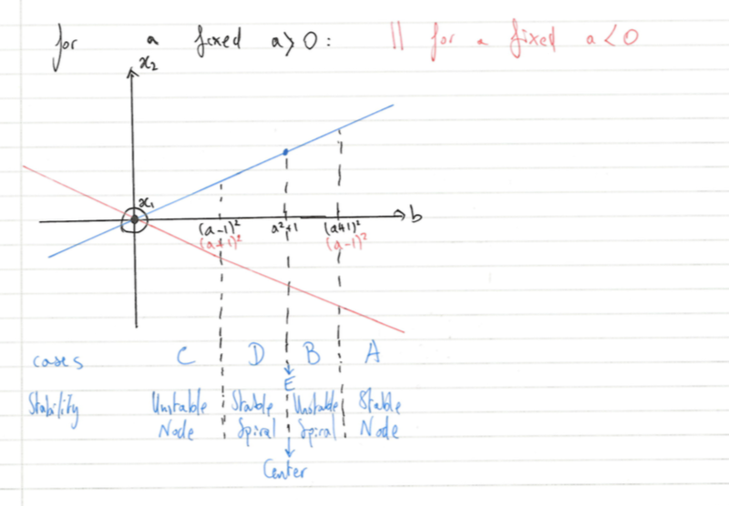

UNSTABLE NODE

STABLE NODE

**The Hopf bifurcation happens when the system goes from stable to unstable, i.e. when b goes from being less than a2+1 to being greater than a2+1.**

**Question 3: The Lotka-Volterra equations: Linear analysis around fixed points**

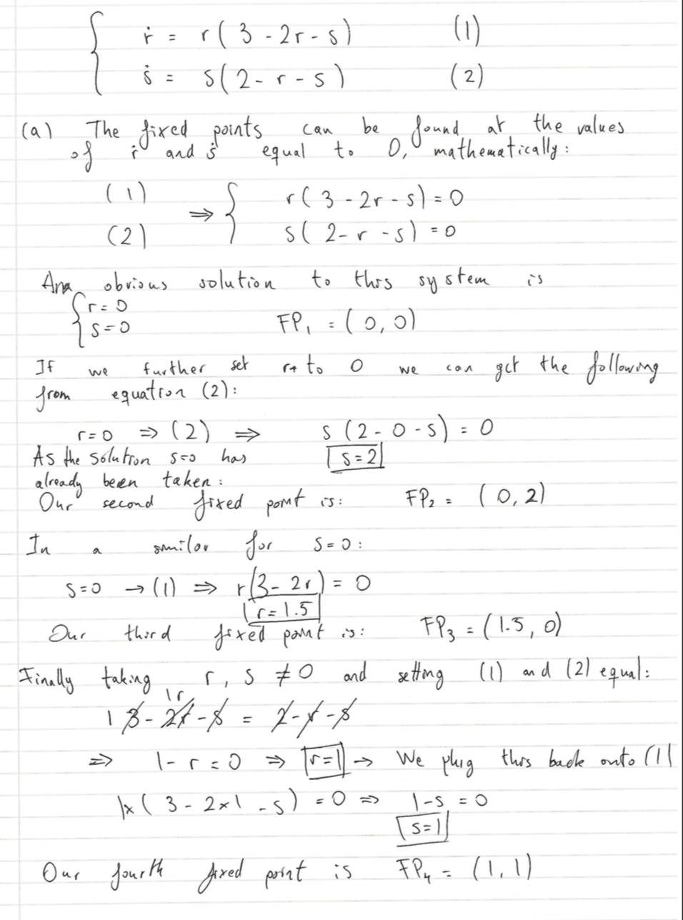**See written solution**

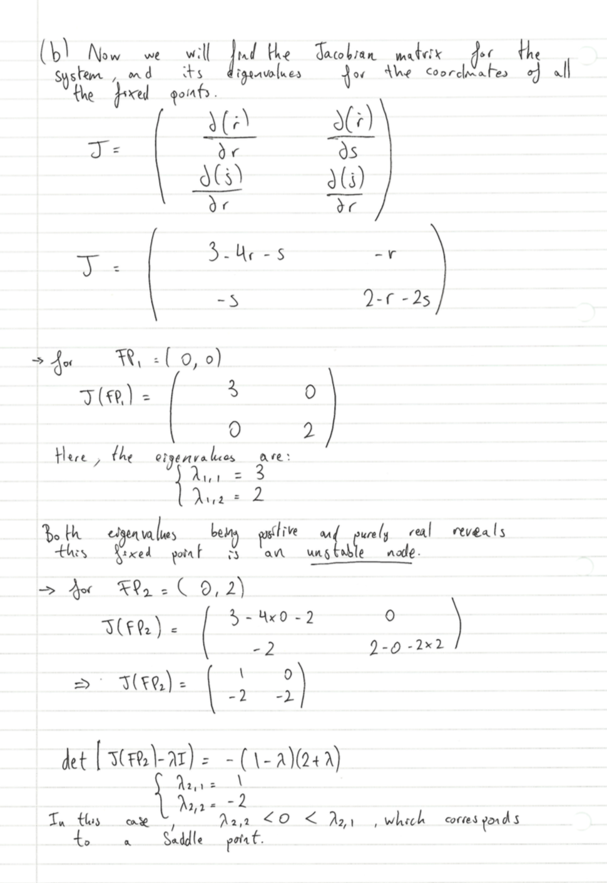

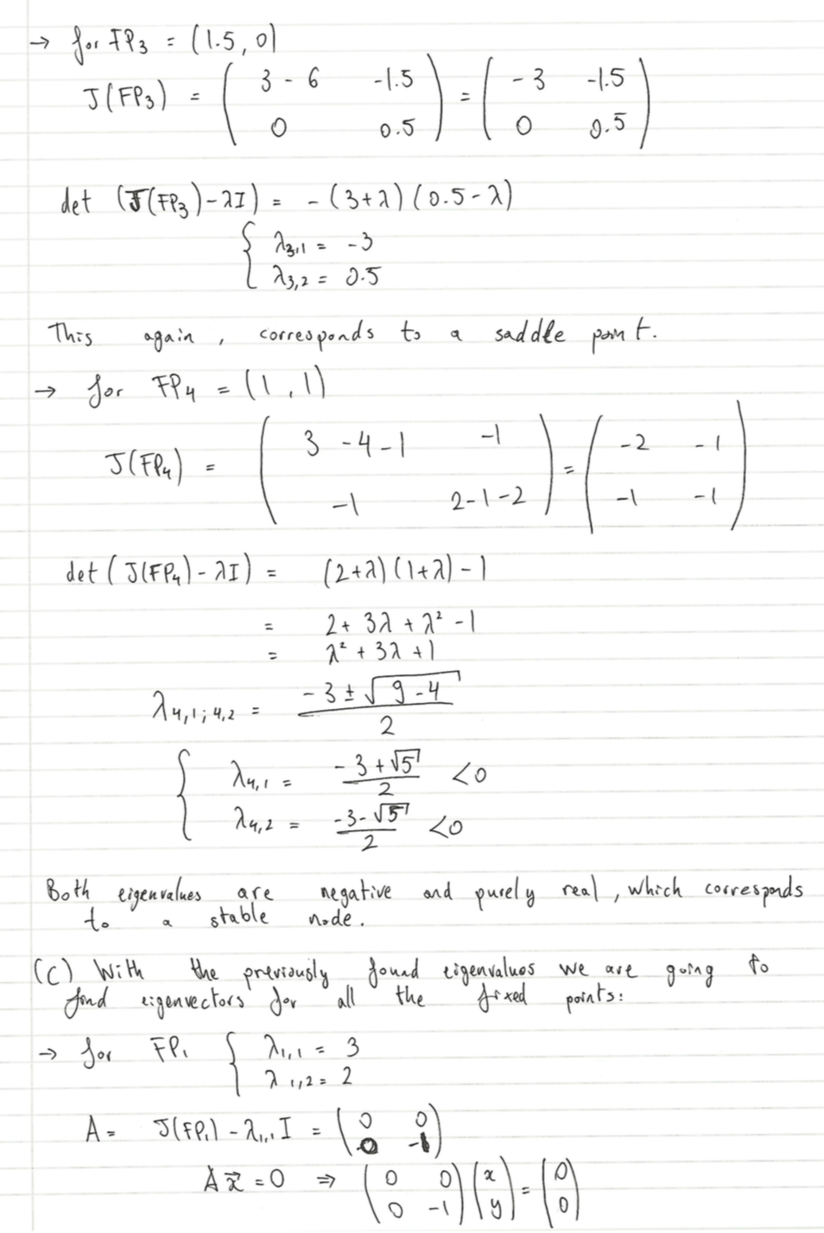

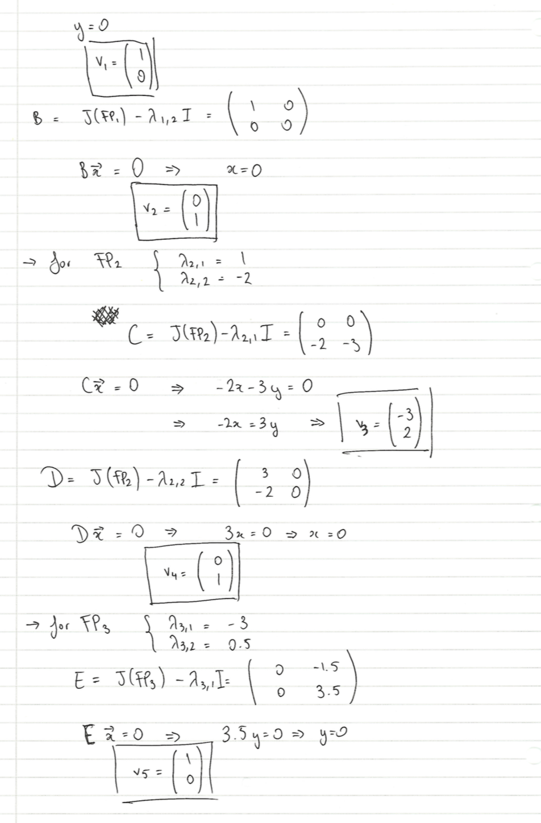

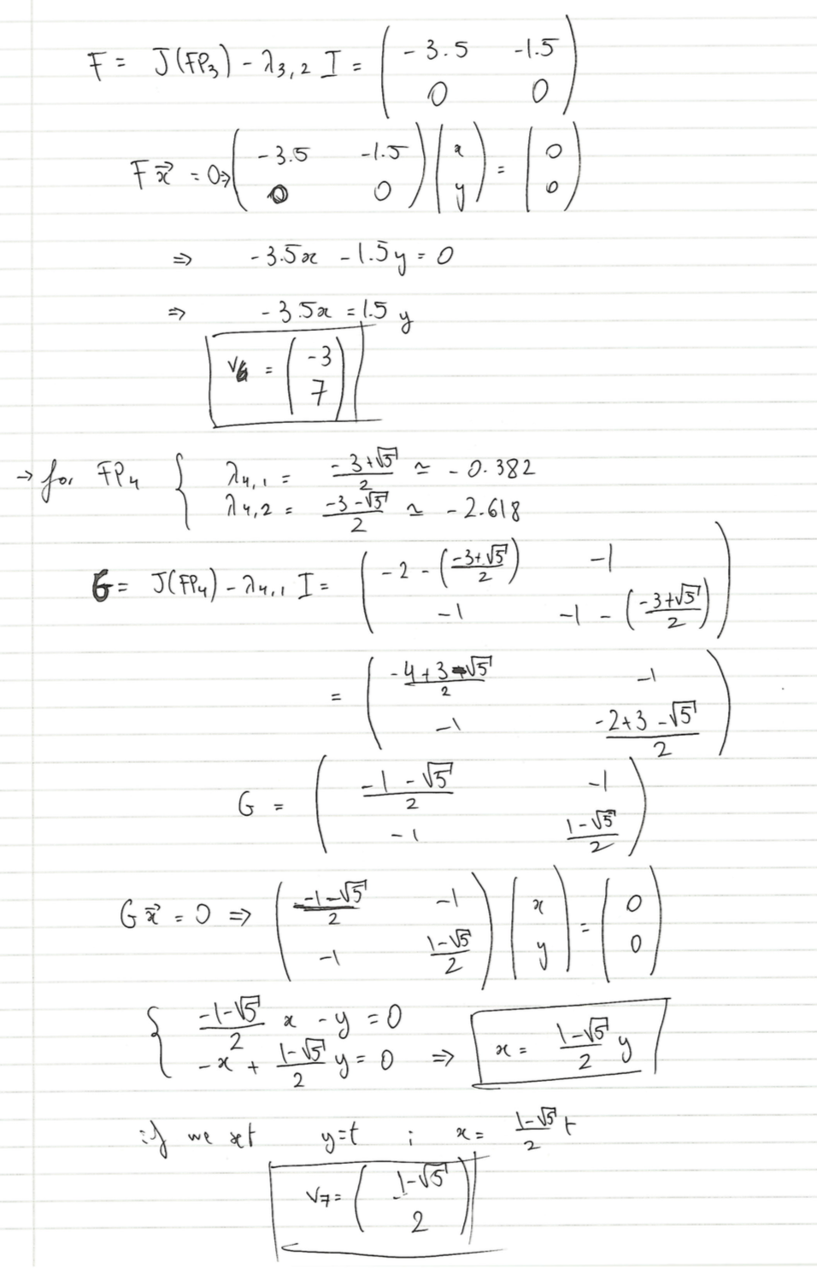

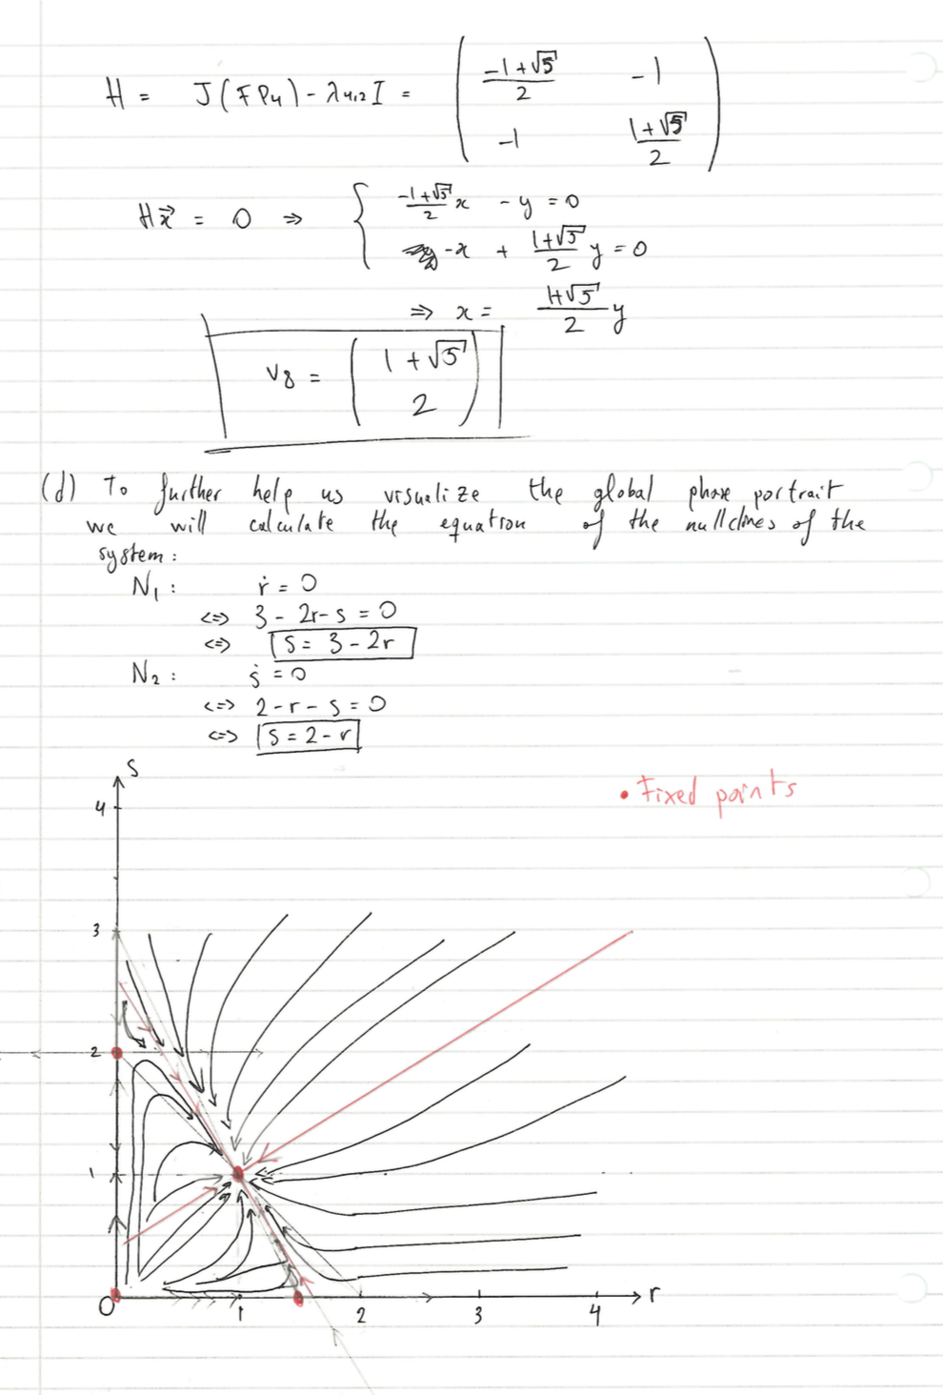

**Question 4: A biological switch** *The code for this question can be seen after the answer to question 4(c).*

(a) The nullclines of the systems are obtained by setting $\dot{x}$ and $\dot{y}$ to 0. After rearranging the following are found:

x-nullcine: $x= \frac{k_{x}}{k_{d}}\left(\frac{1}{1+K_{1}K_{y}y^{2}}\right)$

y-nullcline: $y= \frac{k_{y}}{k_{d}}\left(\frac{1}{1+K_{2}K_{x}x^{2}}\right)$

The x-nullcline can be visualized on figure 1 and the y-nullcline on figure 2. As commented on the MatLab code attached further on in the answer, an increase from 0 to 40 in x makes y go to about a value of 7000 and vice versa. That is the reason why both nullclines cannot be visualized very well on the same plot. Perhaps, both nullclines can be seen plotted on the same graph on figure 3, although at such a scale the graph is not very representative.

The locations of the fixed points (round to the unit or first decimal place) are the following:

FP1: (36.2; 36.2)

FP2: (0; 7143)

FP3: (7143; 0)

After working out the Jacobian matrix of the system and calculating the eigenvalues of the Jacobian for each fixed point the local stability of each fixed point can be deduced:

eig_FP1 =

-2.0929 This correspond to a saddle node.

0.6929

eig_FP2 =

-0.6995 This correspond to a stable node.

-0.7005

eig_FP3 =

-0.6995 This correspond to a stable node.

-0.7005

(b) The trajectories of random starting points with coordinates in the range [0; 7500] can be seen on figure 4. All trajectories seem to be directed towards the saddle node fixed point but then are either directed to one of either stable nodes.



(c) When zooming at the saddle node fixed point (Figure 4b) it can be observed how the trajectories of the starting points bend and change their direction towards the stable node fixed points. The dotted line has equation y = x and is technically referred as the separatrix. If a starting point has a coordinate y greater than x then the trajectory of such point will go near the saddle node fixed point and then end up in the fixed point with a greater y coordinate (FP3: (7143;0)). On the other hand, if the starting point has a coordinate x greater than y then the trajectory of this will finish at the other stable node (FP2: (0; 7142)). In the practically impossible case where concentrations x and y are equal, the optimal equilibrium concentration corresponds to FP1 coordinates (FP1: 36.2; 36.2).

A system of this sort is often referred to as a “biological switch” because by starting above or below the separatrix the system will respectively end up at the fixed point above or below the separatrix.



**CODE FOR QUESTION 4**

%QUESTION 4

%% (a)

%Declaration of parameters

kx = 5000;

ky = 5000;

Kx = 0.5;

Ky = 0.5;

K1 = 0.3;

K2 = 0.3;

kd =0.7;

%Declaration of variables. Note x = fy and y = fx.

syms x y fx fy

x = 0:0.001:8000;

y = 0:0.001:8000;

%Nullclines by setting x-dot and y-dot to 0 and rearranging

fy = (kx/kd)*(1./(1+K1*Ky*y.^2));%Nullcline for x

fx =(ky/kd)*(1./(1+K2*Kx*x.^2));%Nullcline for y

%plot of x-nullcline

figure

hold on

grid on

plot(fy,y,'linewidth',2)

xlabel('x')

ylabel('y')

ylim([0 40])

title('Figure 1: x-nullcline')

%plot of y-nullcline

figure

hold on

grid on

plot(x,fx,'linewidth',2)

xlabel('x')

ylabel('y')

xlim([0 40])

title('Figure 2: y-nullcline')

%Plot of both nullclines on the same graph,

%an increase from 0 to 40 in x makes y go

% to about a value of 7000 and vice versa.

% That is the reason why both nullclines cannot be visualized

%very well on the same plot.

figure

hold on

grid on

plot(x,fx,'linewidth',2)

plot(fy,y,'linewidth',2)

xlabel('x')

ylabel('y')

xlim([-100 7500])

ylim([-100 7500])

title('Figure 4: Phase plane of the system with start points trajectories')

%This section underneath is the computation of the fixed points and their

%plotting on the graph.

func = @testf2;

sol(1,:) = fsolve(func,[40,40]); %Solution 1

sol(2,:) = fsolve(func,[0,7142]);%Solution 2

sol(3,:) = fsolve(func,[7142,0]);%Solution 3

plot(sol(1,1),sol(1,2),'k-o','linewidth',2); %Solution 1

plot(sol(2,1),sol(2,2),'k-o','linewidth',2); %Solution 2

plot(sol(3,1),sol(3,2),'k-o','linewidth',2); %Solution 3

legend('Nullcline for y', 'Nullcline for x','Solution 1', 'Solution 2','Solution 3','AutoUpdate','off')

%Jacobian matrix to find stability of each fixed point

%Jacobian for FP1

ddxdx = -kd;%top-left corner

ddxdy= -kx*2*K1*Ky*sol(1,2)*(1+K1*Ky*(sol(1,2))^2)^-2;   %top-right corner

ddydx = -ky*2*K2*Kx*sol(1,1)*(1+K2*Kx*(sol(1,1))^2)^-2;   %bottom-left corner

ddydy = -kd;   %bottom-right corner

Jacobian1 = [ddxdx ddxdy;ddydx ddydy]

eig_FP1 = eig(Jacobian1)

%Jacobian for FP2

ddxdx = -kd;%top-left corner

ddxdy= -kx*2*K1*Ky*sol(2,2)*(1+K1*Ky*(sol(2,2))^2)^-2;   %top-right corner

ddydx = -ky*2*K2*Kx*sol(2,1)*(1+K2*Kx*(sol(2,1))^2)^-2;   %bottom-left corner

ddydy = -kd;   %bottom-right corner

Jacobian2 = [ddxdx ddxdy;ddydx ddydy]

eig_FP2 = eig(Jacobian2)

%Jacobian for FP3

ddxdx = -kd;%top-left corner

ddxdy= -kx*2*K1*Ky*sol(3,2)*(1+K1*Ky*(sol(3,2))^2)^-2;   %top-right corner

ddydx = -ky*2*K2*Kx*sol(3,1)*(1+K2*Kx*(sol(3,1))^2)^-2;  %bottom-left corner

ddydy = -kd;   %bottom-right corner

Jacobian3 = [ddxdx ddxdy;ddydx ddydy]

eig_FP3 = eig(Jacobian3)

%% (b)

tspan= [0 100];

x0r = 7500*rand([50 2]); %All random values are in the range [0;7500]

%This for-loop plots the starting position and trajectory of all random

%starting points.

for i = 1:size(x0r,1)

    [t,v] = ode45(@(t,v) testf2(v),tspan,x0r(i,:));

    plot(v(:,1),v(:,2),'g','linewidth',0.5);

    plot(v(1,1),v(1,2),'go','linewidth',0.5);

end

%plot of the separatrix

r = 0:0.01:7000;

p = 0:0.01:7000;

plot(r,p,'--')

**Q4 CODE EXTERNAL FUNCTION:**

 function F = testf2(v)

kx = 5000;

ky = 5000;

Kx = 0.5;

Ky = 0.5;

K1 = 0.3;

K2 = 0.3;

kd =0.7;

F  = [kx*(1/(1+K1*Ky*v(2).^2))-kd*v(1);ky*(1/(1+K2*Kx*v(1).^2))-kd*v(2)];

end

**Part 2: Stochastic processes and networks**

**Question 5: Evolutionary dynamics of a DNA nucleotide**

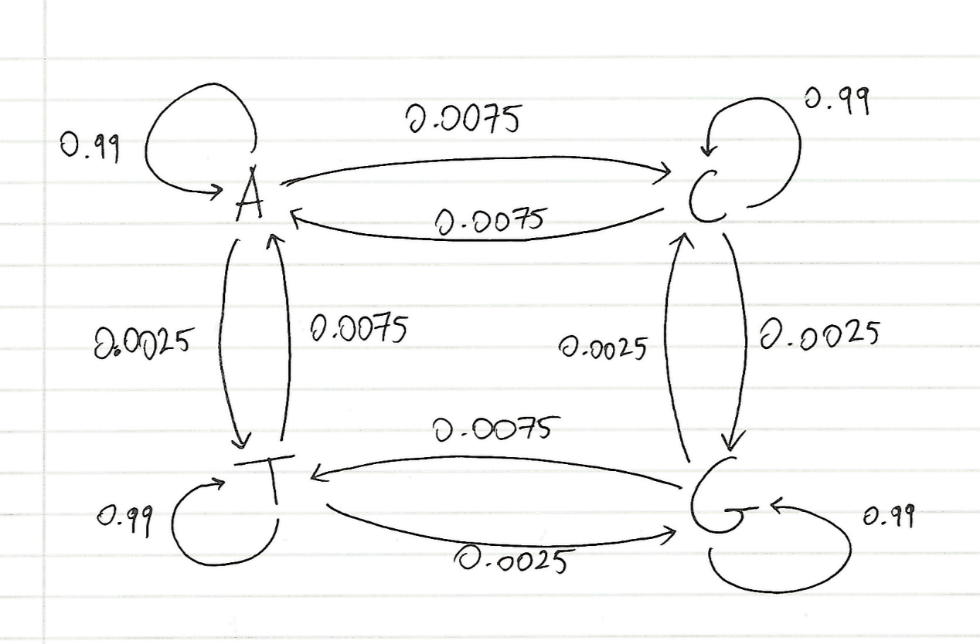(a) Such a stochastic process is calle a discrete-time Markov chian process.  
A diagram of this sytem can be seen on the following sketch:

(b)

Underneath the Matlab code and output with the working out of the stationary distribution ca be found. In the transition matrix rows and columns are in the order A,C,T and G.

**CODE**

%% b

%Declaration of Transition Matrix

T = [0.99 0.0075 0 0.0075;0.0075 0.99 0.0025 0;0 0.0025 0.99 0.0025;0.0025 0 0.0075 0.99];

Transition_Matrix = (T)

%Eigenvalues and Eigenvectors of T

[V,D] = eig(T);

Eigen_Vectors = V

Eigen_Values = [D(1,1) D(2,2) D(3,3) D(4,4)]

%Eigenvalue equal to 1

Eigenvalue_of_Interest = D(2,2)

%Corresponding eigenvector

Stationary_Distribution = V(:,2)/sum(V(:,2))

%Flux from A to C

flux_btwn_AC = Stationary_Distribution(1)*T(1,2)-Stationary_Distribution(2)*T(2,1)

**OUTPUT**

Transition_Matrix =

0.9900 0.0075 0 0.0075

0.0075 0.9900 0.0025 0

0 0.0025 0.9900 0.0025

0.0025 0 0.0075 0.9900

Eigen_Vectors =

-0.6975 + 0.0000i -0.6975 + 0.0000i -0.0000 - 0.0000i -0.0000 + 0.0000i

0.5812 + 0.0000i -0.5812 + 0.0000i -0.7071 - 0.0000i -0.7071 + 0.0000i

-0.2325 + 0.0000i -0.2325 + 0.0000i -0.0000 + 0.0000i -0.0000 - 0.0000i

0.3487 + 0.0000i -0.3487 + 0.0000i 0.7071 + 0.0000i 0.7071 + 0.0000i

Eigen_Values =

0.9800 + 0.0000i 1.0000 + 0.0000i 0.9900 + 0.0000i 0.9900 - 0.0000i

Eigenvalue_of_Interest =

1.0000

The stationary distribution is the normalised eigenvector for which the eigenvalue of the transition matrix equals 1.

**Stationary_Distribution =**

**πA = 0.3750**

**πC = 0.3125**

**πG = 0.1250**

**πT = 0.1875**

**flux_btwn_AC =**

**4.6875e-04**

As the flux from A to C is different than 0, this already tell us that this process does not obey detailed balance as all fluxes are 0 in a system that obeys detail balance. *The flux between A and C is worked out by subtracting the product of the stationary distribution of C and the probability of going from A to C to the product of the stationary distribution of A and the probability of going from C to A.*

(c) On average, it takes 534 generations to go to T from a starting point C.

The matrix named U corresponds to a submatrix giving transition probabilities from non-absorbing states to non-absorbing states. R corresponds to a submatrix giving these probabilities from non-absorbing states to absorbing states.

**CODE**

%% c

U = T;

U(:,4) = []; %we take state 4 as absorbing

U(4,:) = [];

W = inv(eye(3) - U); %fundamental matrix

time_to_T_from_C = sum(W(:,2))

**OUTPUT**

time_to_T_from_C =

533.3333

(d)

The probability that a C evolves into T without first having passed through A is found to be 0.2.

**CODE:**

%% d

U2 = [0.99 0.0025;0.0025 0.99]

W2 = inv(eye(2)-U2) %fundamental matrix

R = [0 0.0075;0.0075 0]

pTbeforeA = R*W2

pTbeforeA_startingC=pTbeforeA(2,2)

**OUTPUT**

U2 =

0.9900 0.0025

0.0025 0.9900

W2 =

106.6667 26.6667

26.6667 106.6667

R =

0 0.0075

0.0075 0

pTbeforeA =

0.2000 0.8000

0.8000 0.2000

**pTbeforeA_startingC =**

**0.2000**

(e)

1. This stochastic process matches all binomial distribution requirements:  
- There is a fixed number of observations, in our case N generations.

- Each generation is independent from the others.

- Each observation represents one of two outcomes, “success” when a mutation happens and “failure” when a mutation does not happen.

- The probability of each success is theoretically the same for each outcome.

Therefore P(M=m) can be expressed as:

$$P\left(M=m\right)= \left({n \atop m}\right)p^{m}{\left(1-p\right)}^{n-m}$$

Where m = 0,1, 2…, n; n is the number of generations your simulations will run for and p is the probability that a mutation happens which is equal to 0.01.

And

2. The expectation or mean μ is equal to np. The variance V is equal to np(1-p).

**CODE FOR QUESTION 5 AS A WHOLE:**

%Q5

%% b

%Declaration of Transition Matrix

T = [0.99 0.0075 0 0.0075;0.0075 0.99 0.0025 0;0 0.0025 0.99 0.0025;0.0025 0 0.0075 0.99];

Transition_Matrix = (T)

%Eigenvalues and Eigenvectors of T

[V,D] = eig(T);

Eigen_Vectors = V

Eigen_Values = [D(1,1) D(2,2) D(3,3) D(4,4)]

%Eigenvalue equal to 1

Eigenvalue_of_Interest = D(2,2)

%Corresponding eigenvector

Stationary_Distribution = V(:,2)/sum(V(:,2))

%Flux from A to C

flux_btwn_AC = Stationary_Distribution(1)*T(1,2)-Stationary_Distribution(2)*T(2,1)

%% c

U = T;

U(:,4) = []; %we take state 4 as absorbing

U(4,:) = [];

W = inv(eye(3) - U); %fundamental matrix

time_to_T_from_C = sum(W(:,2))

%% d

U2 = [0.99 0.0025;0.0025 0.99]

W2 = inv(eye(2)-U2) %fundamental matrix

R = [0 0.0075;0.0075 0]

pTbeforeA = R*W2

pTbeforeA_startingC=pTbeforeA(2,2)

**Question 6: Evolutionary dynamics of a DNA sequence**

1. After 20 generations, the transition matrix is equal to:

**TransitionMatrix_after20steps =**

**0.8298 0.1246 0.0119 0.1246**

**0.1245 0.8278 0.0419 0.0099**

**0.0040 0.0415 0.8219 0.0415**

**0.0417 0.0060 0.1243 0.8239**

**CODE:**

%(a)

T = [0.99 0.0075 0 0.0075;0.0075 0.99 0.0025 0;0 0.0025 0.99 0.0025;0.0025 0 0.0075 0.99];

TransitionMatrix_after20steps = T^20

From the starting sequence to the sequence 1 there are three changes: The first nucleotide is now C and it started being A, the fifth nucleotide is now T and it started being and the second to last nucleotide is now A and is started being C.

According to the transition matrix above, the probability of the first event happening is 0.1245, the second event probability is 0.1243 and the probability of the third event is 0.1246. The probability of these two events happening is therefore 0.0019.

From the starting sequence to the sequence 2 there are two changes: The third nucleotide is now T and it started being C and the second to last nucleotide is now T and is started being C.

According to the transition matrix above, the probability of the first event happening is 0.006 and the second 0.006. The probability of these two events happening is therefore 3.6x10-4.

Therefore the most likely sequence after generation is sequence 1.

1. After 100,000 simulations the average number of generations until the whole sequence is different from the starting sequence is 1014.

**CODE**

%% Q6

tic

%(a)

T = [0.99 0.0075 0 0.0075;0.0075 0.99 0.0025 0;0 0.0025 0.99 0.0025;0.0025 0 0.0075 0.99];

TransitionMatrix_after20steps = T^20

%(b)

%Starting sequence

%A is 1, C is 2, G is 3, T is 4

Sequence0 = [1 2 2 4 3 1 2 2 1]

%number of generations

n = 0;

% 10000 simulations

for i=1:100000

%Declaration of a Sequence that will change after each generation

Sequence = Sequence0;

%while any of the nucleotides from Sequence is equal to Sequence0 the

%code will keep running (i.e. another generation will exist)

while Sequence(1)== Sequence0(1) || Sequence(2)== Sequence0(2) || Sequence(3)== Sequence0(3) || Sequence(4)== Sequence0(4) || Sequence(5)== Sequence0(5) || Sequence(6)== Sequence0(6) || Sequence(7)== Sequence0(7) || Sequence(8)== Sequence0(8) || Sequence(9)== Sequence0(9)

for a = 1:9

%%check what nucleotide is the initial one

if Sequence(a) == 1

start = 1;

end

if Sequence(a) == 2

start = 2;

end

if Sequence(a) == 3

start = 3;

end

if Sequence(a) == 4

start = 4;

end

eventprob = rand; %random number between 0 and 1

temp = 0; %temporary variable that is going to hold the increasing probaility

reactid = 0;

for c=1:4

%the probability will be chosen from the previously selected

%start column and this for loop will browse through every

%row c

temp = temp+T(c,start);  %goes to starting nucleotide column

if temp>=eventprob

%if the chosen rate is not bigger than

%eventprob go to the next one

reactid=c;

break

end

end

%Change nucleotide

if reactid == 1

Sequence(a) = 1;

end

if reactid == 2

Sequence(a) = 2;

end

if reactid == 3

Sequence(a) = 3;

end

if reactid == 4

Sequence(a) = 4;

end

end

n = n+1; %%adds up for every generation

end

end

%Average number of generation over number of simulations.

avgNumber_of_Generations = n/100000

toc

**OUTPUT**

Sequence0 =

1 2 2 4 3 1 2 2 1

**avgNumber_of_Generations =**

**1.0138e+03**

Elapsed time is 125.203772 seconds.